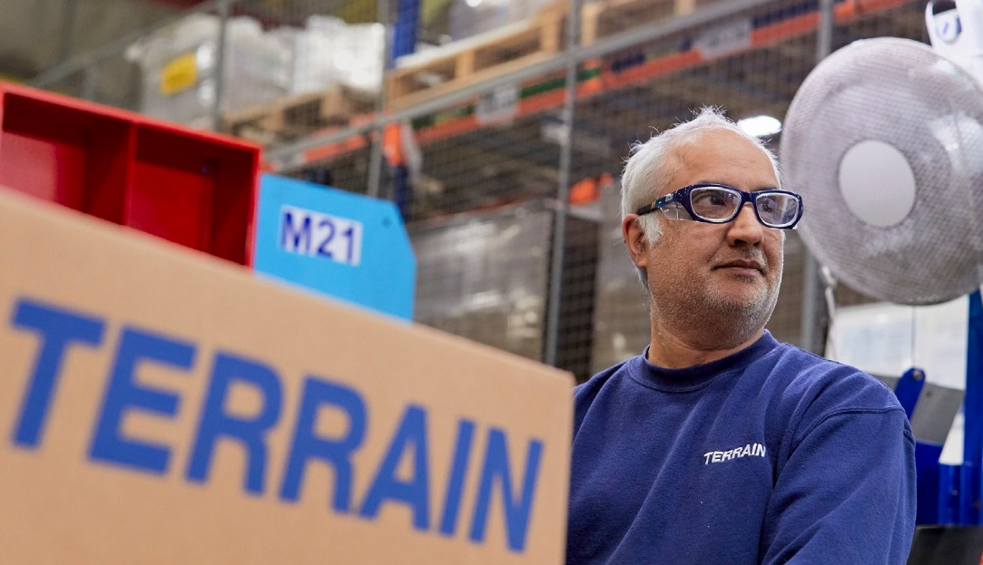
WE ARE

HIRING

POLYPIPE BUILDING SERVICES, NEW HYTHE BUSINESS PARK AYLESFORD, ME20 7PJ

Supply Chain Warehouse

Key Accountabilities:

Pick, check and prepare customer orders ready for outbound loading and despatch accurately and presented to a high standard both within the Warehouse and Outdoor Yard areas using a Voice Recognition System.

To be successful you will:

- Excellent communication skills.
- Demonstrated Good Team Behaviours and willingness to learn.
- Ability to be trained and the use of Manual Handling Equipment.
- Computer literate – Working Knowledge of system applications.

Supply Chain Warehouse – Outbound Operative – Part Time

We currently have a vacancy to join out Outbound Team on a 6 Month Fixed Term Contract within our Supply Chain Warehouse Operations department at our Aylesford site.

Shift Patterns

Day Work- 3pm to 7pm.
20 Hours per week – Monday to Friday.

Join us:

Are you seeking an opportunity where the business puts Health and Safety first and is committed to developing its people, building knowledge and expertise in Supply Chain Operations.

APPLY NOW!

If you think you are the perfect fit for the role, please send your CV to the email below:

Vinesh Mehta
Supply Chain Operations Manager
Vinesh.Mehta@Polypipe.com

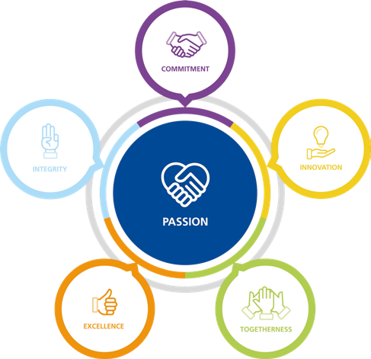

Polypipe Building Services operate an Equal Opportunities Policy
Building Services

