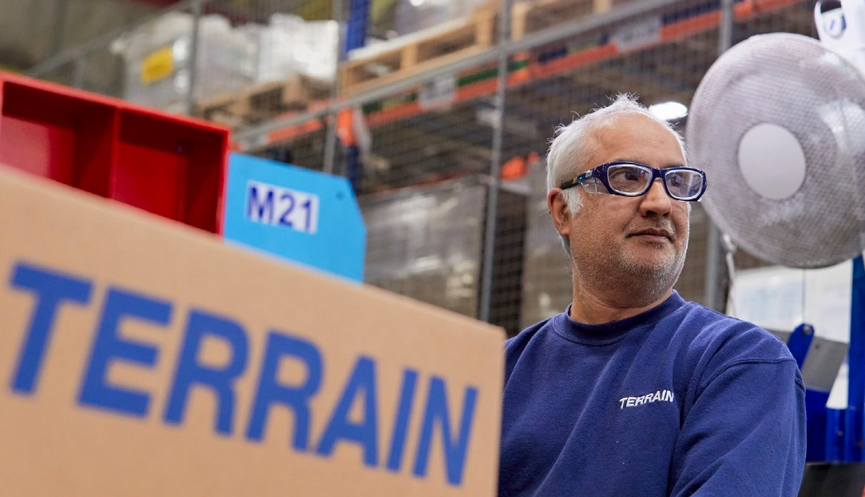
WE ARE

HIRING

POLYPIPE BUILDING SERVICES, NEW HYTHE BUSINESS PARK AYLESFORD, ME20 7PJ

TRANSPORT VACANCY

Key Accountabilities:
The successful candidate will be expected to be extremely flexible in their approach to the duties and hours required, they must have very high attention to detail, focus and be keen to work as part of a team. Candidates will be required to learn to drive MHE and occasionally this role may require nights out

To be successful you will:
The successful candidate must have the following knowledge, qualifications and skills/experience:
- Applicants MUST have a full UK Category C+E LGV Licence
- Applicants MUST have a current DCPC Qualification card
- Knowledge of Road Transport & Working Time Legislation
- Focused attention to detail
- Good geographical awareness
- Flexible approach to duties
- Excellent Communication
- Excellent Customer service skills

Join us:

We are currently looking for an exceptional candidate to join our team as a Tramper Driver, Category C+E.

Based at the Aylesford Depot, the successful candidate will provide Polypipe Building Services with a professional driving service to meet and exceed expectations of our customers.

Hours of work:
Monday to Friday, various times, inc nights out
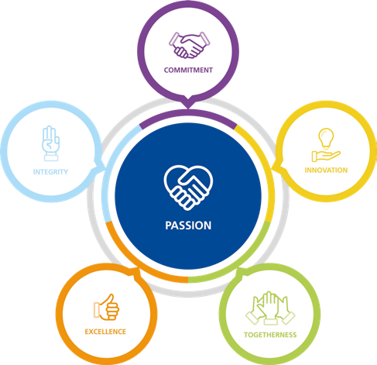

APPLY NOW!
If you think you are the perfect fit for the role, please send your application by email, with a current CV, having first advised your line manager to:
Lindsay Nolan-Wilcox
Operations Manager - Transport
Lindsay.Nolan-Wilcox@polypipe.com

Polypipe Building Services operate an Equal Opportunities Policy
Building Services

