Prepare your home for Winter

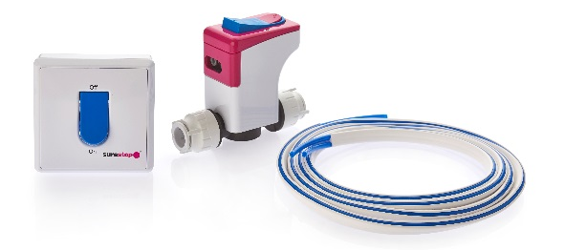
In the UK, our Winter conditions adversely affect many homes, causing water pipes to expand and rupture in properties and ultimately causing irrevocable damage, as well as triggering what has been reported as the most common type of homeowner insurance claim during the winter period – the escape of water, as a result of burst water pipes.

That said, this widespread household winter insurance claim could be avoided through some basic preparation tips.

In late Autumn and during Winter, regularly check pipes around the house for bulges or frost covering. A frozen pipe is not always visible and typically tend to occur during Winter, when a property is unoccupied for a length of time, particularly throughout the Christmas period. Turning off your mains water supply before leaving the house unoccupied for a winter holiday, could consequently prevent wider damage caused by a potential burst pipe.

For a homeowner, tenant or landlord, a burst pipe is a major maintenance disaster. According to insurance provider, MORE TH>N, a burst pipe at mains pressure will leak up to 400 litres of water per hour (two baths full). Regularly checking them could help avoid such disasters.

The main water valve in a home is what controls the water flow and in case of an emergency, every appropriate home occupant should be able to locate and easily access their mains water valve, or as it is also known as, the stopcock. This is however not often the case. According to leading insurer Direct Line, only 82% of homeowners and 57% of tenants know the location of the stopcock controlling the water mains into their home.

Direct Line also reported, that the average household cost for damage caused by a burst water pipe is £7,000, as a result of flooding, serious structural damage and potential mould damage if immediate action is not taken. This not only affects a homeowner financially, but also causes huge emotional distress, especially if sentimental items or household goods are destroyed as a result of a burst pipe or leak.

Traditionally brass stopcocks have been the control valve for a home’s mains water supply, however they are not always located in the easiest of places to reach and due to being susceptible to limescale damage, can be quite difficult to turn off in an emergency. For older residents or those with varying abilities especially, this poses a huge problem particularly during winter, when pipes are more prone to bursting.

There is however now a modern alternative to brass stopcocks, which is a UK manufactured, Surestop stopcock. Fitted in easy to reach places, the Surestop stopcock features a lockdown button, that can be simply and easily pressed to instantly stop the water supply. There are no electrics or batteries involved, it works purely on the water pressure and it will not seize up or be affected by limescale – unlike brass. The Surestop stopcock is also available with a version that includes a discreet, remote lockdown switch, that could be fitted in a kitchen cupboard or surface area, for even easier access and visibility.

Whatever type of stopcock has been installed, it is critical to know where the stopcock in your home is, in case you discover a burst water pipe or a leak develops. In rented accommodation, it is also important that a landlord makes tenants aware and ensures it has been fitted in an easy to access location. Plumbers, Heating & Plumbing Engineers and Installers also need to consider this when fitting a stopcock into a new property or a refurbishment i.e. Kitchen.

If you know areas of your house are more exposed to the outside frost, consider insulating any pipes within that area. Our lofts in the UK are also more effected by cold winter conditions, therefore insulating any pipes within a loft is always a good method for further protecting a home.

What to do if your pipe bursts:
- Immediately turn off your mains water at the stopcock. If a Surestop stopcock is installed, simply press the lockdown button on the stopcock or if a version with the Surestop remote switch is installed, just flick its lockdown switch. If a brass version is installed and it has seized up and you or other occupants are unable to stop the mains water, seek urgent help from a qualified plumber
- Once the water supply is off and isolated, turn on the cold taps to release any water sat within the pipes and flush the toilet repeatedly. Do this exercise again for the hot taps, after turning off the heating system. This will finally drain the remaining water out of the pipes
- Urgently call a professional plumber who will be able to replace the section (s) of the burst pipe and consult with your insurance company
- For future protection, if a brass stopcock is installed, consider getting a Surestop Stopcock fitted. There will be no need to remove or use the brass version, but the Surestop model should be installed in an easy to access location

Our Winter checklist ….

Just to recap, our recommended winter checklist for homeowners, landlords, tenants and trade are:
- Regularly check pipes around the house for bulges or frost
- If leaving the house empty for an extended period of time or for a winter break, turn-off your mains water supply, as a precautionary measure
- Know where the stopcock is located and that all the home’s occupants also know where it is
- If a brass stopcock is fitted, make sure it has not been effected by limescale and seized up; for better and quicker protection and access, consider asking a plumber to install a Surestop version
- Insulate outside pipes that are often exposed to frost, as well as pipes running through cold loft spaces
- Make sure all appropriate occupants know what to do if a pipe does burst and how to react quickly
Surestop are part of Polypipe, the UK’s largest and most trusted plastic piping systems manufacturer, where quality, support and innovation are of the upmost importance.
For further information on the Polypipe Surestop products, please go to www.polypipe.com/surestop or call 08456 431800.
ENDS
For more information on this article, please email marketing@surestop.co.uk or call +44 (0) 1302 348826

