WE ARE

HIRING

POLYPIPE BUILDING SERVICES, NEW HYTHE BUSINESS PARK AYLESFORD, ME20 7PJ

ADVANTAGE VACANCY

Key Accountabilities:

Responsibilities may include:
- Ensure that outputs / standards for the manufacture of fabricated products are met or exceeded
- Ensure product is fabricated from drawings supplied by the Advantage Department
- Design and manufacture jigs and fixtures for the purpose of producing fabricated products
- Select and print appropriate labels where applicable to attach to fabricated products
- Programme work for fabrication in conjunction with planning department

The ideal candidate will the following knowledge, experience, skillset and behaviours:
- The ability to interpret technical drawings for manufacture
- Experience of working in a fabrication role (not necessarily with plastic)
- Demonstrated practical experience in a workshop environment and use of hand and powered tools
- Prioritise their workload to deadlines
- A willing to learn and develop with the team
- Attention to detail and ability to measure accurately is a must

Join us:

We are currently recruiting for 2 Fabricators to join our Advantage department at our Aylesford Site.

Our Fabricator will ensure that quality products are fabricated and assembled in a timely and cost-effective manner whilst applying a culture of continuous improvement, which in turn will deliver excellent customer services and value for money alongside achieving the correct fabrication standards and therefore contributing to maximising departmental performance.

The hours of this role are 8 am – 4 pm on Monday - Thursday
and 6 am – 12 pm on Friday i.e. 38 hours per week

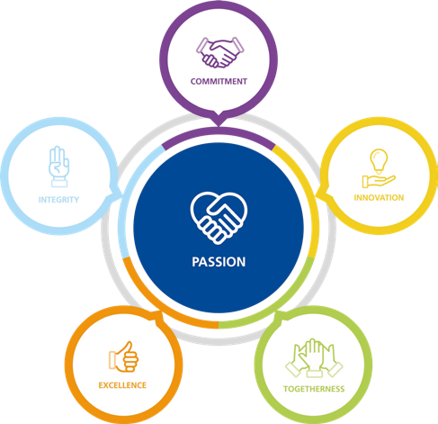

APPLY NOW!
If you think you are the perfect fit for the role, please send your application by email, with a current CV to:
Mark Smithurst
Advantage Team Leader
Mark.Smithurst@polypipe.com

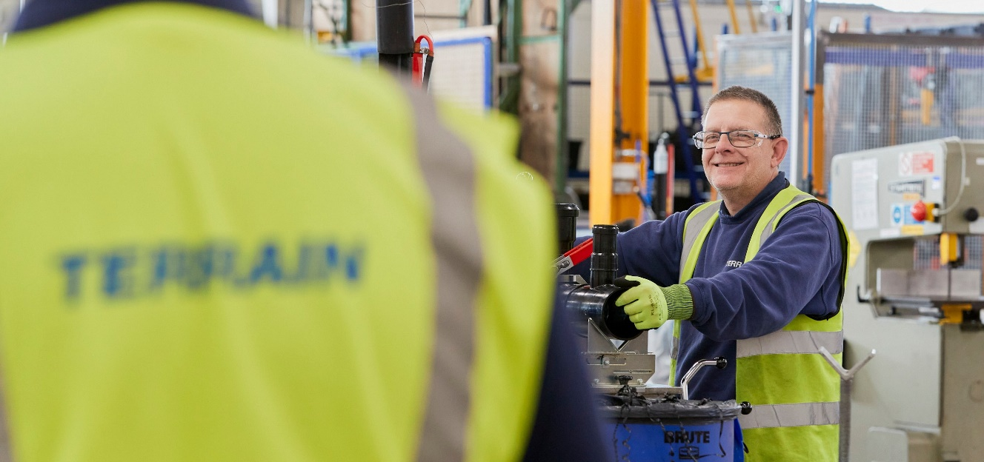
Building Services
Polypipe Building Services operate an Equal Opportunities Policy

