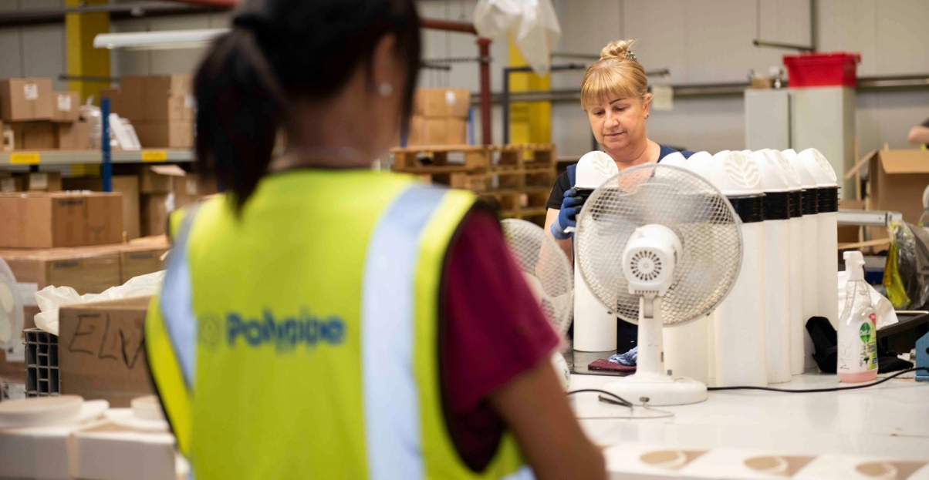
WE ARE

HIRING

POLYPIPE BUILDING SERVICES, NEW HYTHE BUSINESS PARK AYLESFORD, ME20 7PJ

INJECTION MOULDING VACANCY

Join us:

We currently have a vacancy for a Shift Team Leader in Injection Moulding.

Hours of work:
The position is on 3 rotating shifts, 40 hours per week, Monday - Friday.

Key Accountabilities:

The Team Leader is responsible for ensuring all the resources and processes within the Injection Moulding area are controlled effectively, that the team works according to SSW, and that all KPI targets are communicated and achieved. They must also be able to motivate and drive their team to identify and implement continuous improvement initiatives.

The successful applicant will require:
- Knowledge of Injection Moulding processes and equipment.
- Excellent communication skills and able to arrange and chair meetings.
- Excellent problem solving skills working in isolation and part of a team.
- Commitment, drive and reliability.
- An excellent timekeeping and attendance record.
- The ability to work on their own initiative.
- Leadership skills – previous supervisory experience will be an advantage.
- Lean manufacturing knowledge would be an advantage.

The vacancy is for a hands-on Team Leader therefore the successful applicant must also have the skills to carry out the duties of one of the following roles as well as leading the team: Production Operator, Tool Setter, Service Person or Production Technician.

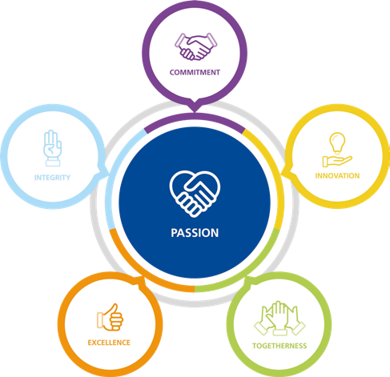

APPLY NOW!
If you think you are the perfect fit for the role, please send your application by email, with a current CV to:
Carl Pollard
Production Manager

Carl.Pollard@polypipe.com

Polypipe Building Services operate an Equal Opportunities Policy
Building Services

